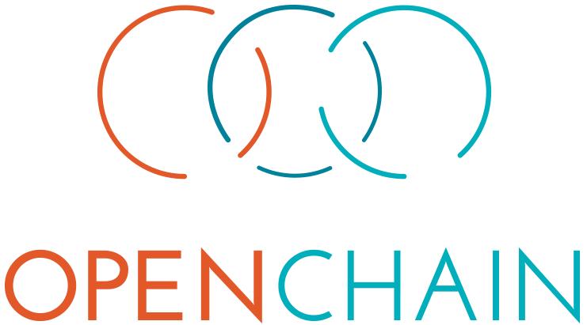

For Managers

The OpenChain Project identifies key recommended processes for effective open source management. This reduces bottlenecks and risk when using third-party code.

OpenChain can be explained in five sentences.

1. The OpenChain Project makes open source license compliance simple and consistent in the supply chain.
2. OpenChain Specification defines the core requirements of a quality compliance program.
3. OpenChain Conformance helps organizations display adherence to these requirements.
4. OpenChain Curriculum provides basic open source processes and best practices.
5. The result is open source license compliance becomes more predictable, understandable and efficient for the software supply chain.

OpenChain is building the industry standard for license compliance. It can be understood as the foundation for open source compliance in the supply chain. Engagement and adoption is simple, free and supported by a vibrant community backed by leading multinationals across multiple sectors.